create database ecommerce;



use ecommerce;



SOURCE C:/Users/joker/Desktop/Internship/Day3/customers.sql

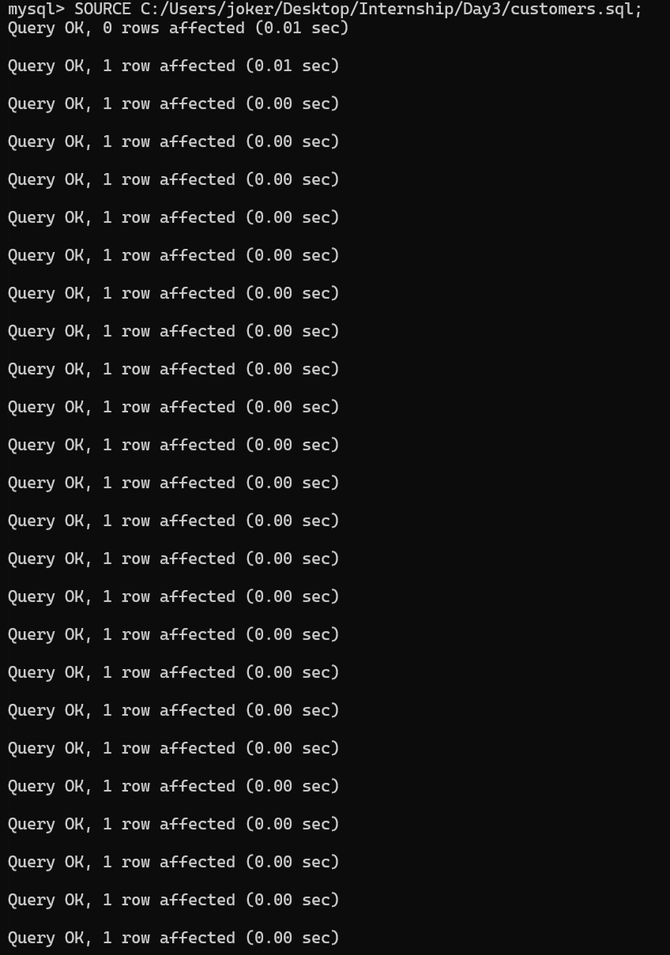
Queries

1. View all transactions from France

SELECT * FROM customers
WHERE Country = 'France'
ORDER BY InvoiceDate;

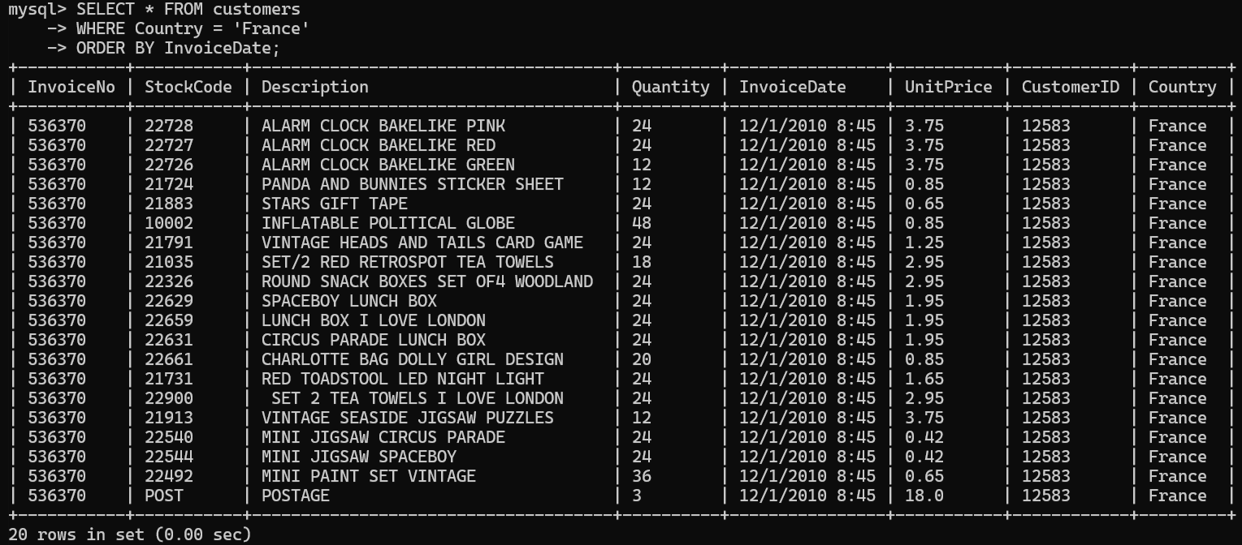

2. High-value items (price > 10)

SELECT InvoiceNo, Description, UnitPrice FROM customers
WHERE UnitPrice > 10
ORDER BY UnitPrice DESC;

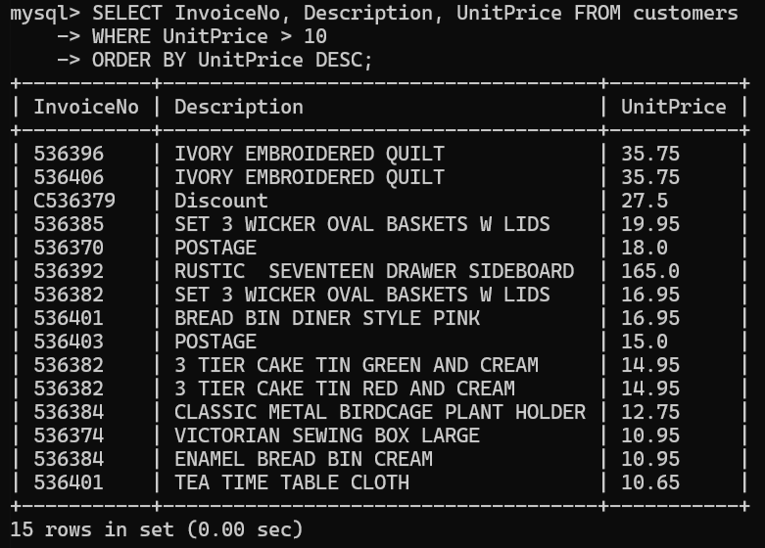
3. Total sales per country

SELECT Country, SUM(Quantity * UnitPrice) AS TotalSales
FROM customers
WHERE Quantity > 0
GROUP BY Country
ORDER BY TotalSales DESC;

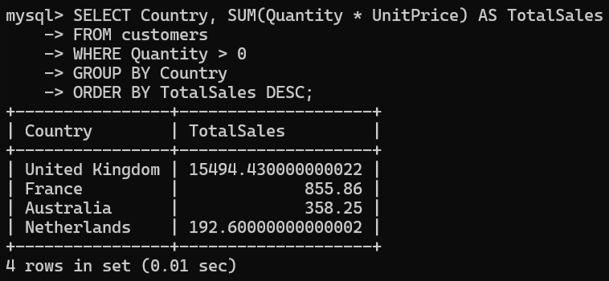

4. Average order value per customer

SELECT CustomerID, AVG(Quantity * UnitPrice) AS AvgOrderValue
FROM customers
WHERE Quantity > 0
GROUP BY CustomerID
ORDER BY AvgOrderValue DESC;

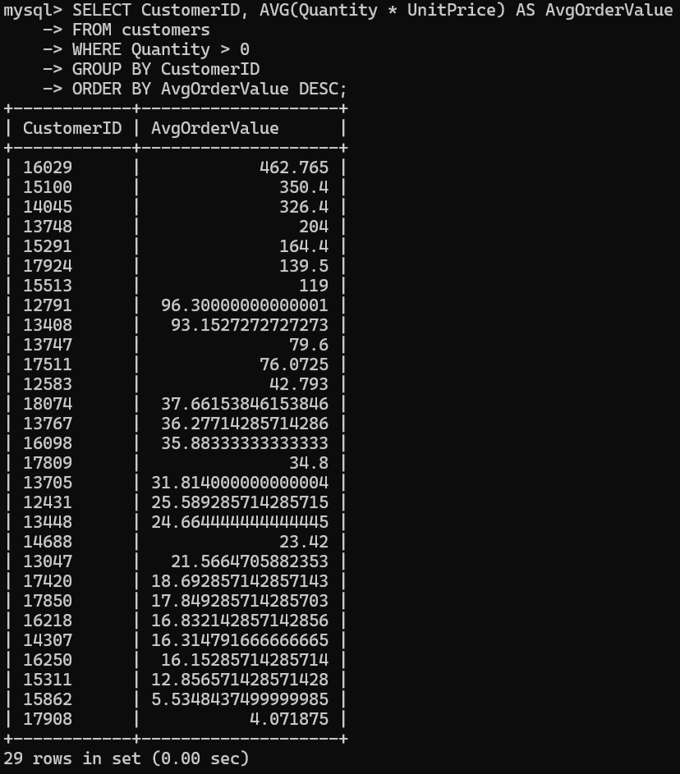
Views

1. Customers View

CREATE VIEW customerzz AS
SELECT DISTINCT CustomerID, Country
FROM customers
WHERE CustomerID IS NOT NULL;
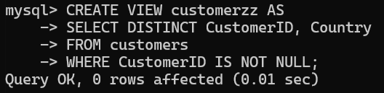

2. Products View

CREATE VIEW productzz AS
SELECT DISTINCT StockCode, Description, UnitPrice
FROM customers;
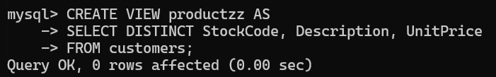

3. INNER JOIN – customer purchases
SELECT c.CustomerID, p.Description, t.Quantity, t.UnitPrice
FROM customers t
INNER JOIN customerzz c ON t.CustomerID = c.CustomerID
INNER JOIN productzz p ON t.StockCode = p.StockCode;
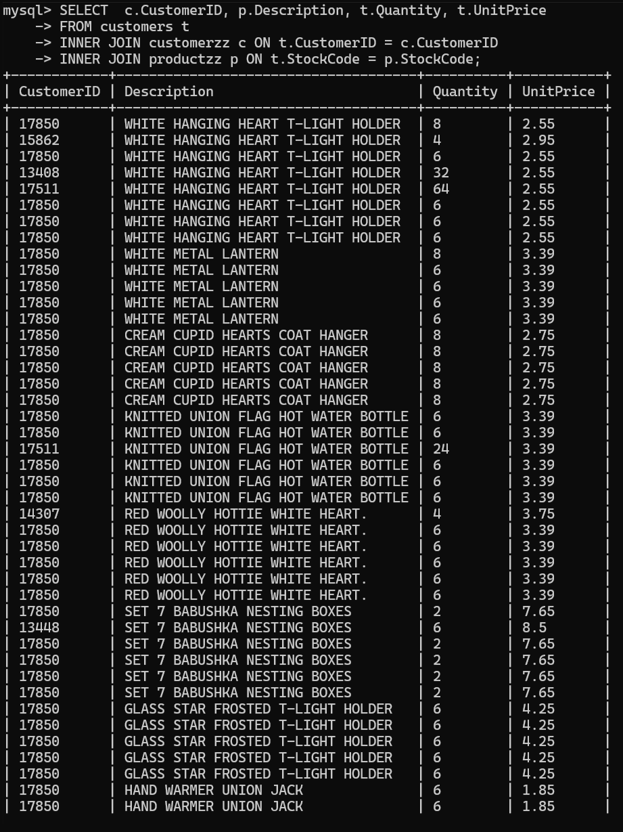

4. LEFT JOIN – customers even if no purchases
SELECT c.CustomerID, COUNT(t.InvoiceNo) AS TotalTransactions
FROM customerzz c
LEFT JOIN customers t
ON c.CustomerID = t.CustomerID
GROUP BY c.CustomerID;

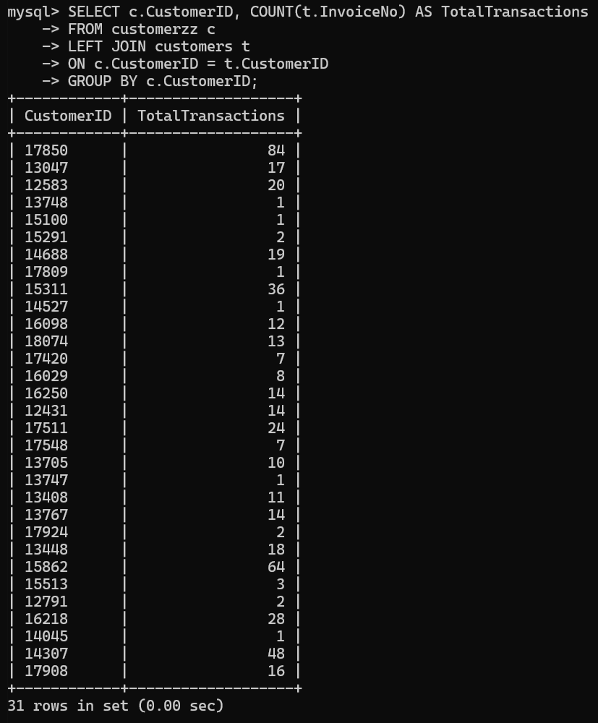

Subquery

5. Find products whose price is higher than the average product price
SELECT StockCode,Description,UnitPrice
FROM customers
WHERE UnitPrice > (SELECT AVG(UnitPrice) FROM customers);

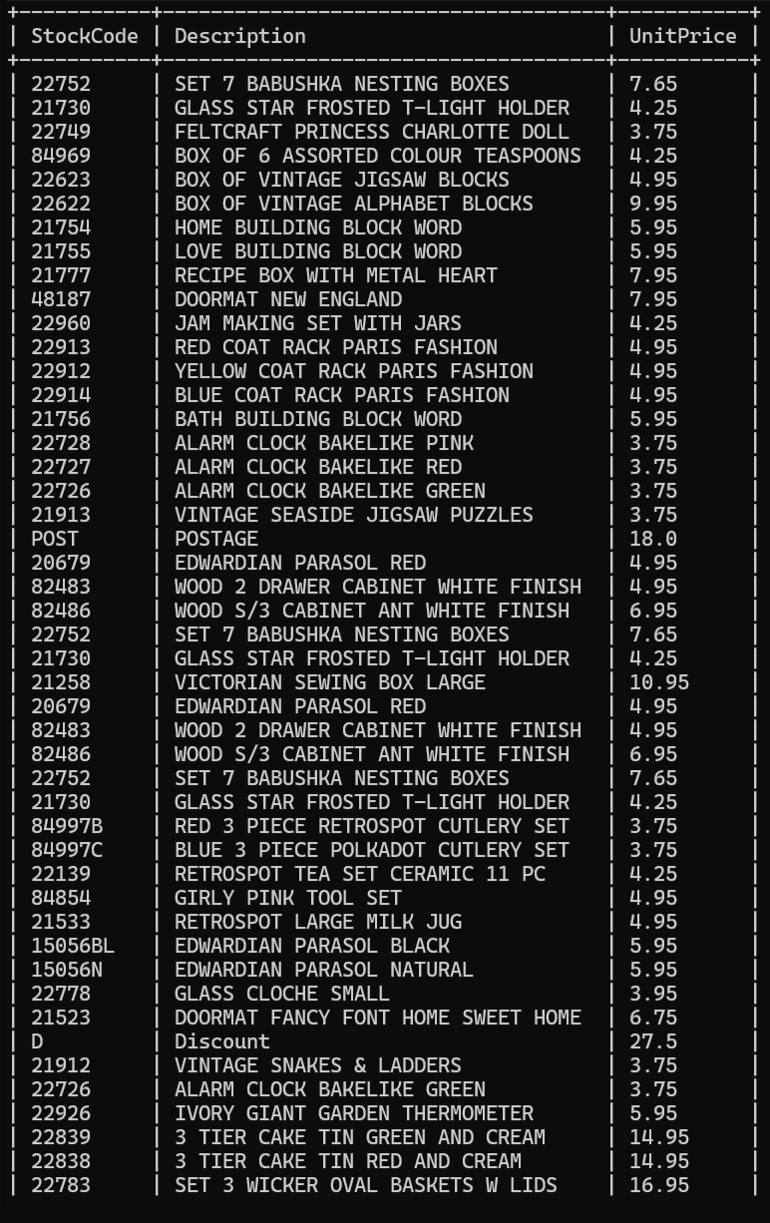

Views For Analysis

Sales summary view
CREATE VIEW sales_summary AS SELECT InvoiceNo,CustomerID,Country, SUM(Quantity * UnitPrice) AS InvoiceTotal
FROM customers
WHERE Quantity > 0
GROUP BY InvoiceNo, CustomerID, Country;

SELECT * FROM sales_summary ORDER BY InvoiceTotal DESC;
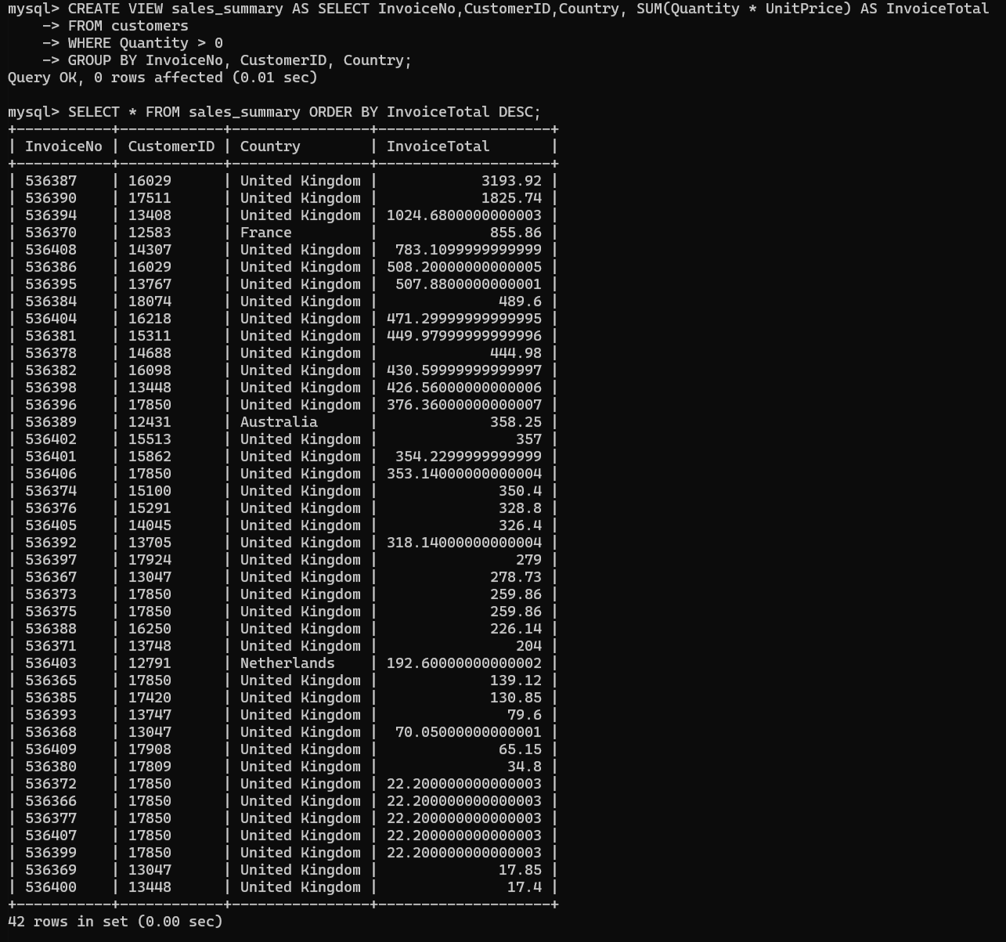
Index Optimisation

CREATE INDEX idx_customer_id ON customers(CustomerID(50));
CREATE INDEX idx_invoice_no ON customers(InvoiceNo(50));
CREATE INDEX idx_country ON customers(Country(50));

